Whenever you create reaact native application then you can see many files and folder which are made automatically and auto generated What are there use What is inside them we will see it in this part
what are their benefit We will know what is the purpose of a file
If you want to change something for something then in which file to bring the change
Where to create new file
Where your aapllication is being registered
What is the entry point of JS( who knows)
you will know everything

So first our focus will be on the files and folder important for beginners
then we will explain the remaining files and folder
At last some interview question will be asked
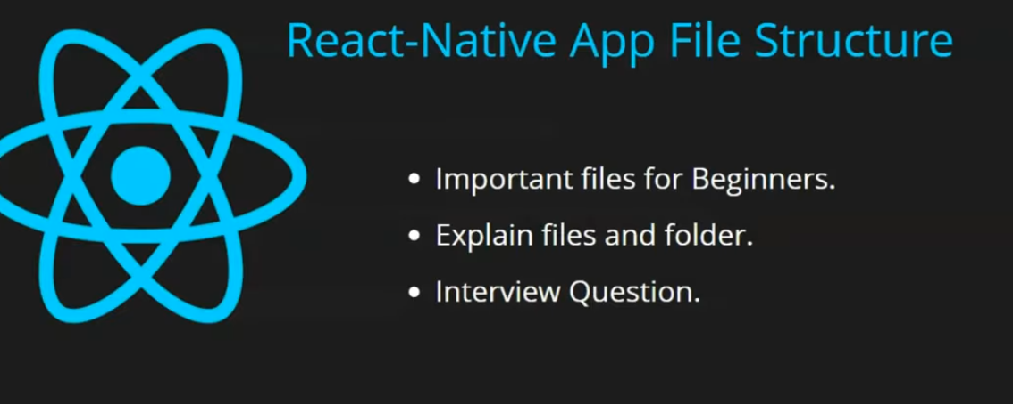

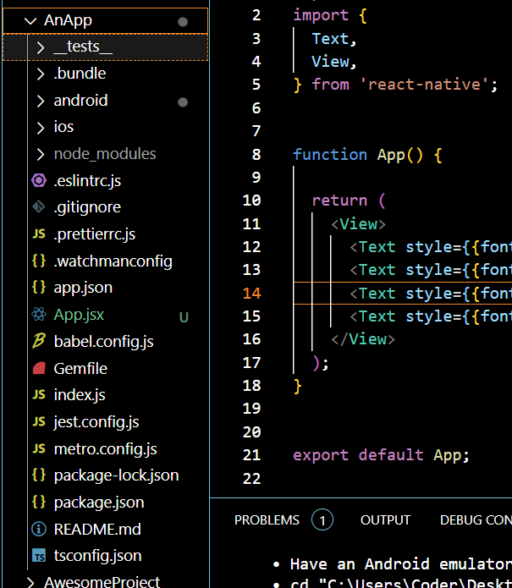
The above is our application files you cn see above all teh files These files and folders are auto generated when you create react native application
We have not created anything in these files
We just modified App file in previous lesson leaving it we have not added any file or bring chnge in teh file
So before starting with files lets see important files which is important for beginners

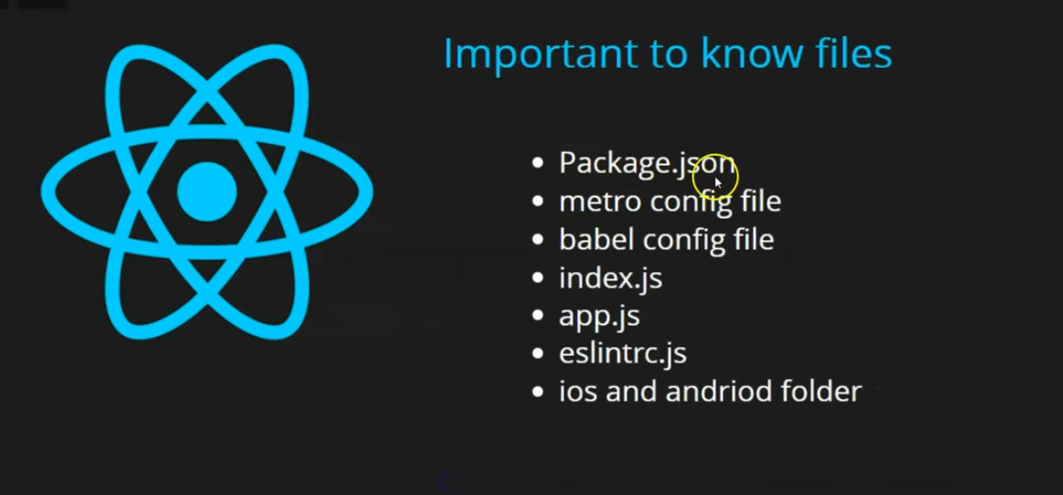
All the above files, node modules and folder are important for beginners and they shold know there uses becaause it can happen you have to change(edit) them in future

because it may happen that you may need to bring some changes in it

you should also know about remaining files but if you cannot understand them properly then it works
We have just started projects you will understand them gradually
but these are important things
Many important interview qquestion also come out of it
First file is Package.json
It is the most important file in an app
If you delete this file or don't have any backup of it then you project will not run
the usage of this file is that it keep all the information of your project
This file contains name of the project, version , script of your project
that you use to run,build your project or do some configuration or operation on the project
Its example is
npx react-native run-android

Through this you can run your app in android emulator
2:14
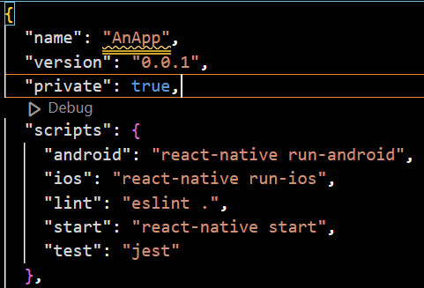
it also tell us what are the scripts These are the cammand that we run
by concatenating with npx (means we take resources online)
So as in our above script key there are many internal key specifying the context of their respective cammand which is hownas its value so as you can see android key has value "react-native run-android"
so if we run cammand react-native run-android then it will open the project in the android emulator
but if we rename the "expo start –android" to "expo go –android"
then we can start the android emulator by npx go –android
I don't know ehy it is not happening but it works according to the teacher
________________________________________________________________________________
Note:-
react-native run-android
you don't have to reload the app everytime to see the change here if you save your file then its changes will be shown in the app
________________________________________________________________________________
there are many dependencies and dev dependencies here
you can change the version of the dependency you are using by editing the respective package version in the dependency and maybe install it later by npm install
Whenver you install a new library
suppose you are making a form then for its validation or you need google Map then you install a library then
whatever library you add will be registered here in the dependencies key
along with their version number as its values
So basically project important informaation is gathered here
teacher will teach us package-lock.json later as you can become confused
but as the tacher said previousy that our focus is on other files
Now comes our file that is metro_config.js
below is old look
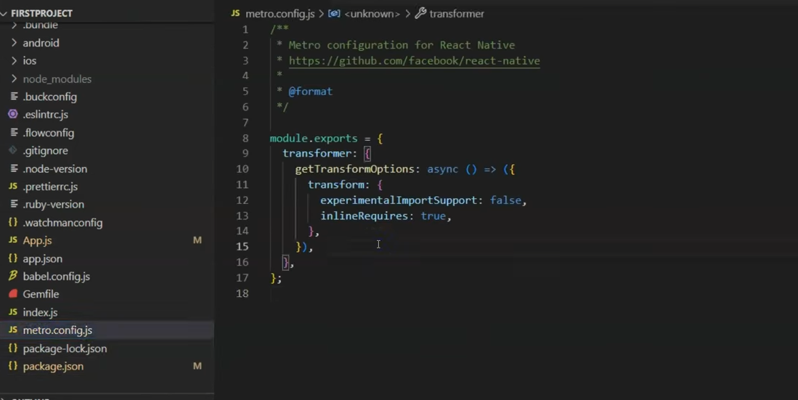
Below is new look

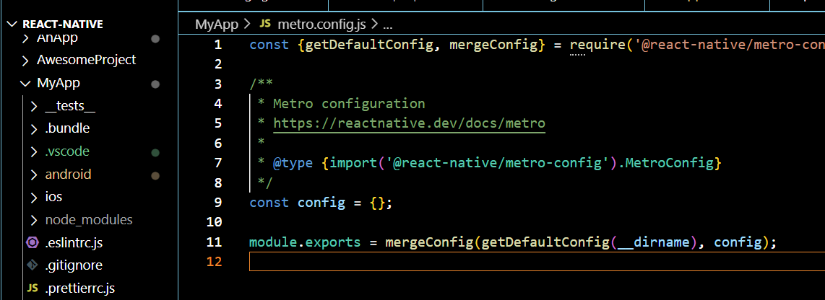
This metro config make your application reload fast and compile it fast
You must have observed that when you save the file of apps then your app gets reloaded aand then changes are implemented very fast
To implement this change fast and reload you application fast
All these work is of metro_config.js
If you want to change configuration then you need to edit metro_config.js
what to change how to change it we will read it
because for now our focus is on purpose we are not coding it actully
next thing that comes is babel.config

what is ecmascript aand can wwe use it as a replacement of javascript

ECMAScript is a standardized specification that defines the rules, syntax, and features for scripting languages like JavaScript. It serves as the foundation upon which JavaScript (and other languages like JScript and ActionScript) is built. The specification is maintained by a group called ECMA International, and its primary purpose is to ensure consistency and compatibility across different implementations of scripting languages.

Can ECMAScript replace JavaScript?
No, ECMAScript itself cannot "replace" JavaScript because ECMAScript is essentially a blueprint for JavaScript (and similar languages), not an actual programming language that you write and run directly.
JavaScript is an implementation of ECMAScript, and browsers or environments (like Node.js) use JavaScript engines (like V8 in Chrome) to execute ECMAScript code. So, when you write JavaScript, you are typically writing code that adheres to the ECMAScript specification. JavaScript has its own ecosystem, additional features, and runtime environments built on top of ECMAScript.
In short, ECMAScript is the standard, and JavaScript is the language built around that standard. You can't directly "use" ECMAScript as a replacement for JavaScript, but when you work with JavaScript, you're using the ECMAScript specification as the basis for the language.

Many times you write code of ecmascript suppose we write a latest javascript code
then Javascript compiler(maybe used to cinvert js code to native code thai is java for android and swift c for ios) in our android system(maybe android browser) or browser (when you create react application) then this file is used as your browser or android appliction cannot understand the latest code
then inside it you do the configuration which convert the latest code to old code
you know preciously we used to do javascript then comes the ecmaascript and thne come ecmacript 15,16, 17 it goes on . So it convert the latest code to convert it into the code the browser or Android is compatible with
nd you can do configuration here to what code version you want to change it to and you can also tel l the thing you want to change you can configure everything here
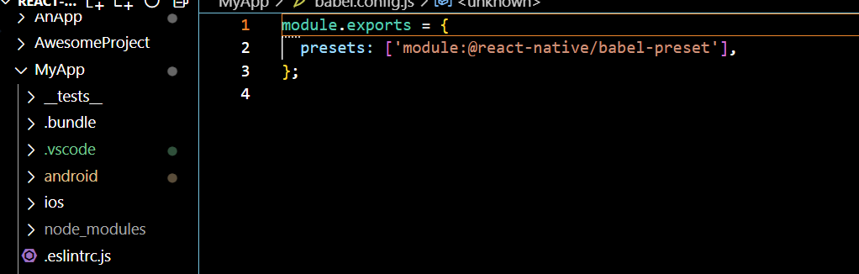
(babel_config.js)
and then comes index.js
I think it does not exist anymore
you can call it javscript entry point or the app entry point (i think so )
Whatever component you make gets registered here
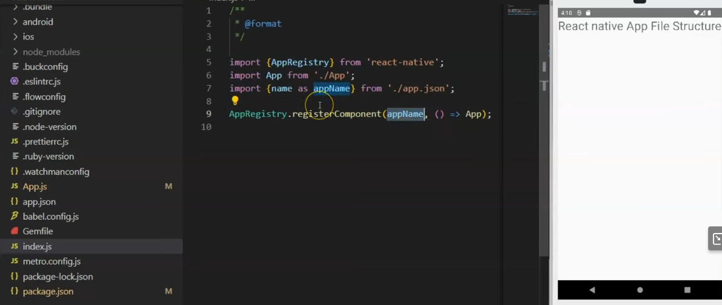
It is the first default component you see after the creation of your app
it had the default code of UI you see in your app (as it is by default registeerd in index.js)
You can delete app.js and can make another component of another name or rename the app with another name but then you need to replace app word with the new name in index.js(maybe as components are registered there) and also in renamed app.js
By default whatever code output you see in emulator is by default is written in app.js
Now comes eslintrc.js
It does not exist anymore in modern file structure
es in eslintrs is Ecma Script
If you want that it must support a version of Ecma(maybe rules or regulation)
and inside your project there is unused variable
then you want to show error for them
or you add console then there is error
So whatever configuration exist in ecmascript it exist here
Now comes android or IOS folder in our file structure

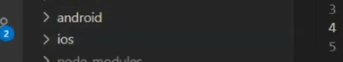
The android and ios contains files required for the compilation of their respective platform build
and to create its build they are responsible for it
if you install any external library or you want some change in the dependency then sometimes we have to bring changes here but these chances are very less
When react native was very new then we used to do it but not now
but its main purpose is that to compile your code into android or ios aand when you create a build then convert javascript code into native code
We have done important files

______________________________________Expo______________________________________
Note:-
To cater different needs the reactnative has templates in expo
these are:-

default | Default template. Designed to build multi-screen apps. Includes recommended tools such as Expo CLI, Expo Router library and TypeScript configuration enabled. Suitable for most apps.
blank | Installs minimum required npm dependencies without configuring navigation.
blank-typescript | A Blank template with TypeScript enabled.
tabs | Installs and configures file-based routing with Expo Router and TypeScript enabled.
bare-minimum | A Blank template with native directories (android and ios) generated. Runs npx expo prebuild during the setup.

blank and bare is for javascript
________________________________________________________________________________

and Now we will see remining files
Interview question
What is package-lock.json
It keeps dependency of dependency
Now suppose there is a library whose dependency is on another library and that library has dependedncy on another package Now these heirarchial structure is stored in package-lock.json
So package.json keep the information of the app and the packagh-lock.json keeps their heirarchial structure of dependencies
Sp pckage.json keeps our application information
and package-lock.json keeps the information of the dependencies like what other dependencies they depend on aand keep the heirarchial structure
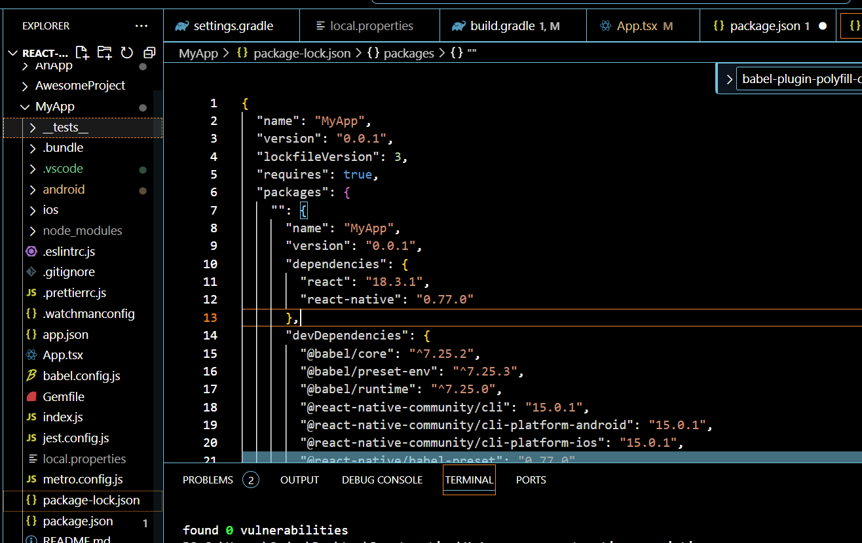
Now comes Gemfile:-
This is made for Ruby
Now you will say what is the work of ruby here
Now when you want to debug your ruby application then that teim ruby become helpful to us
So whatever dependency you want to give to ruby or the chamges you want to do in its configuration you can do so in this file
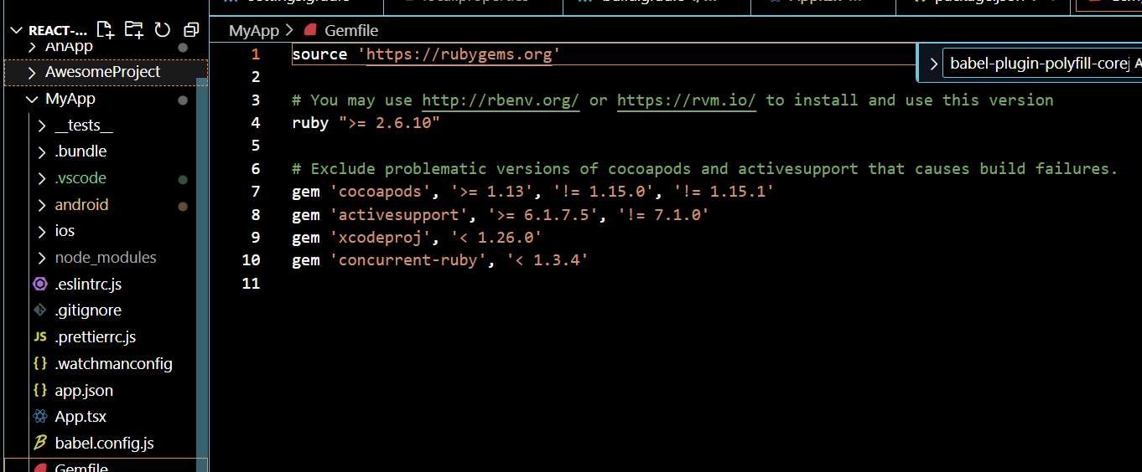
Now comes app.json
there will be your project name or display name these are the basic information which is stored in this json file
watchmanconfig is used to detect changes in our app when ctrl + s is clicked and it works with metro
and related to it hen to detect change if you want to configure it then you can do so
and implementation or load will be done by the metro
So when we edit a file and then to save it press ctrl + s then the watchmanconfig will detect the change and change will be implemented by metro
In watchmanconfig you can do change the configuration such that when you need to detect the changes and when you don't need to detect the changes and i think the changes that was not detected will not be implemented in the emulator in anptehr aord to renable the checnge or disable teh changes(who knows) you will see all the configuration
Now comes the ruby-version file which store the version number that we are using but it is not present in the modern file structure
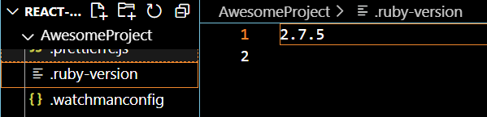
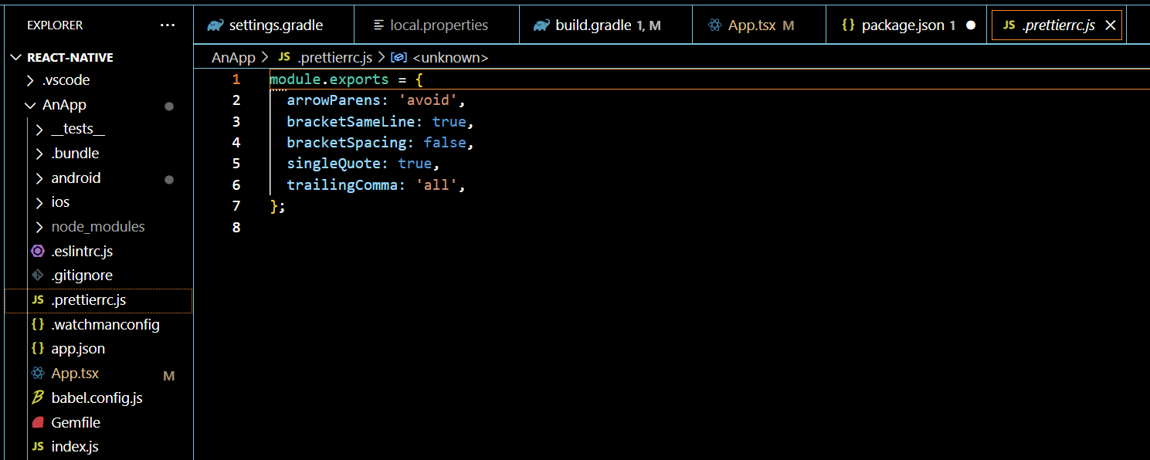
Now comes the prettierc.js
I think this manages the formatting in the compiled code
I think the native code that is formed after the compilation of javascript (or maybe just javacript) is formatted here
like how many spaces you need, use single quotes or double quotes.What you want to avoid
So it helps in your code formatting
node_version is the file telling that what version of node we are using and which is supported (who knows).It is not present in the modern file structure
Now we will talk about gitignore
In this file we tell teh name of the files that we don't want to push to git server
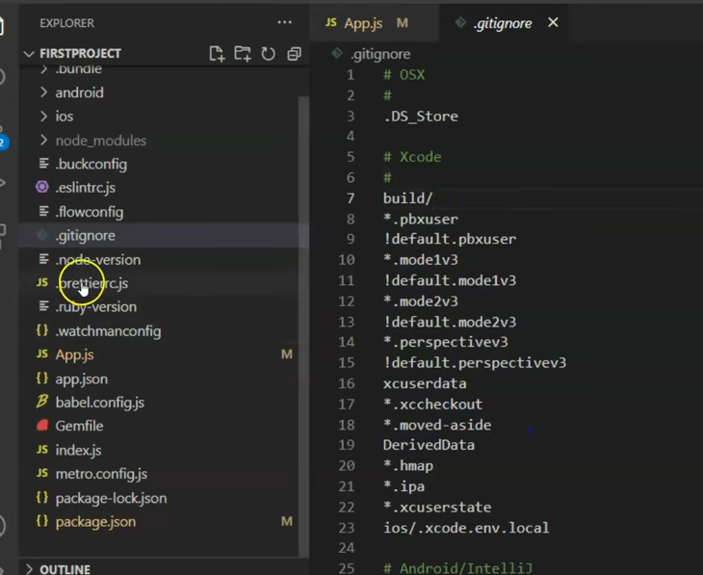
In git you don't push node_modules folder because it is heavy weight and could be generated by
suppose you make a folder for storing components anf you don't want to push it in git you put that name in the gitignore then the file will not be pushed

Now comes the .flowconfig not present in the modern file structure

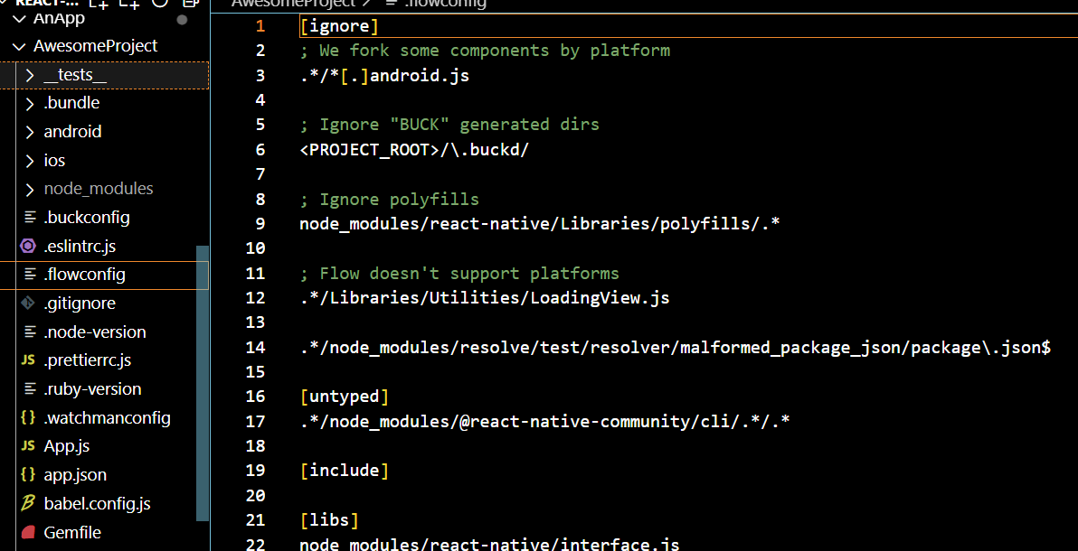
The code that get compiled in your application then what will be the fl;;ow inside it
whihc library will be consumed first and which willl be compiled later if you waant to configure then you can do so(who knows) if you want to aadd nay external library then you can do so here
It has the same working as polyfillls file in Angular(who knows)

now comes the .buckconfug
It is also not present in the modern file structure
It tells that in your syytem which platform you are supporting
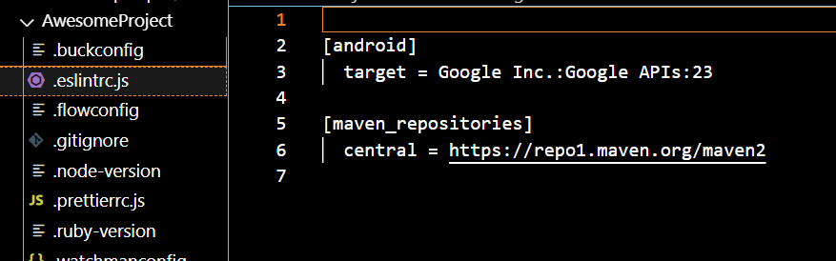
From above we are supporting API 23
if you want to change the supportd API tehn you could change the target
Now comes the node modules
whataver libraries are installed will be shown here
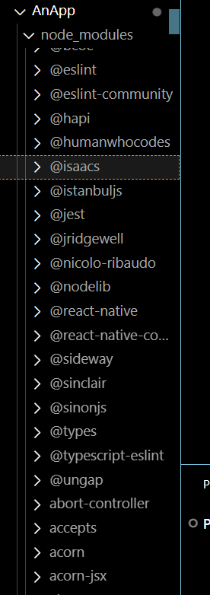
You may think that package.json is very small aand mention very less packeges but in node modules there are large number of package
because whatever libraries we needed and mentioned in package.json are as usaul present in the node modules but internally they need other packages as well due to which they are included in thr node modules
so whatever packages is in your application will be listed in the node modules
and you don't push node modules folder in git becasue there large files and they can be generated through packaage.json by executing the cammand node install
So we don't need that much
Now comes the .bundle folder
It will be used when you are bundling your application for android or ios platform (maybe build)
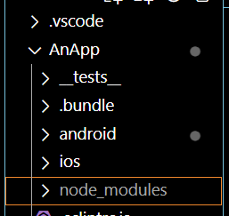
Now comes the __test__ folder It
It is used for unit testing
The unit testing code ois auto generated here
but You can also write your own code here
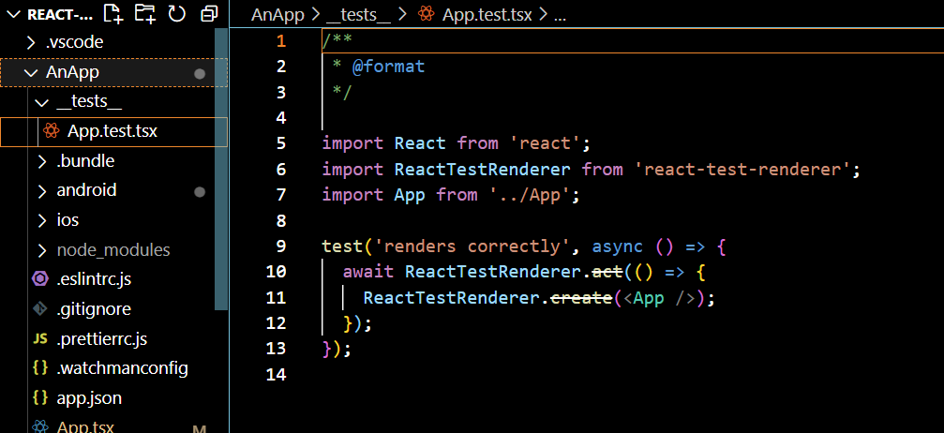
Suppose we make a function and you wanmt it to test it
then write it here thern it will be compiled (who knows maybe a making a new file in __test__ folder)
In Interview question they may ask you
why node modules are not pushed in the git
What is the use of package.json
Difference between package.json and package-lock.json
What is the entry point of the application
They can ask you about watchmanconfig
In our next part we create a new file and a new component we will learn something new

